**Working of the project**

**This project folder has few components which include the python file, html file and another folder to store the downloaded mp4 and mp3 files.**

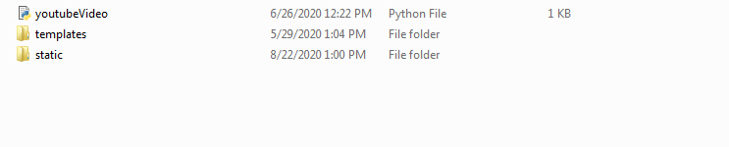

* The youtubeVideo python file is the core of this project.

Mainly two functions are created that,

1. Takes youtube video URL and downloads and stores it in the static folder.
2. Converts the downloaded mp4 file to mp3 format.

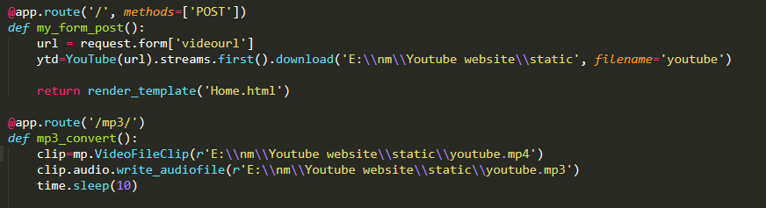

* **We create two different folders-**

1. “**static”** folder is where the downloaded video mp4 file and the converted mp3 file be stored.
2. **“templates”** folder has the html file for this project.

* **We run the python file in terminal**

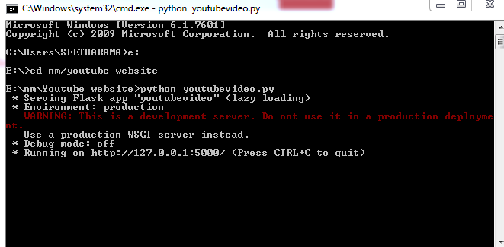

* As shown in the image to get the project interface we go to localhost: **127.0.0.1:5000** and we get the below web page displayed

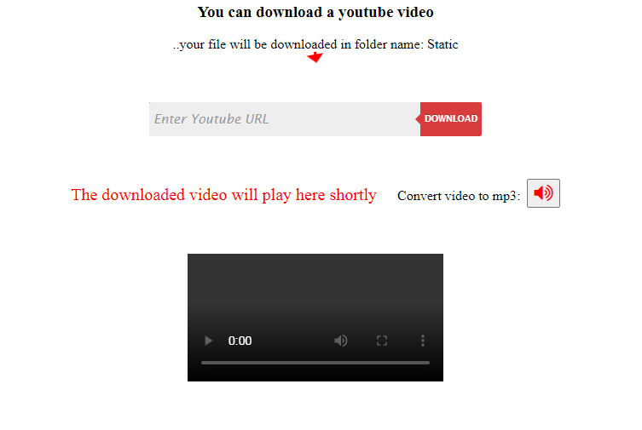

* As shown we have to type the URL of a youtube video to download it and the downloaded video will be displayed in the black region below.

We enter the URL in the search bar:



And press Download button.



* The file will be downloaded in the static folder and displayed on the website

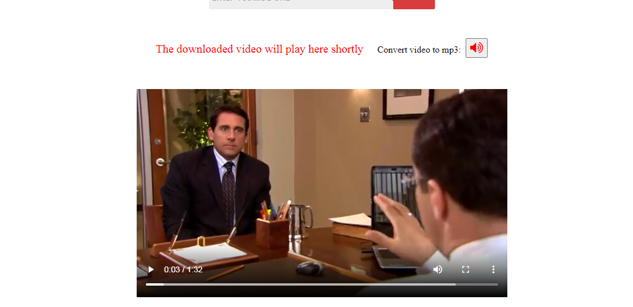

* **Now if you want to convert it into an mp3 file for example:**

If someone wants to download a song and does not want a video but just the audio then after downloading the YouTube video, he can press the "**convert video to mp3**" button to convert it to mp3 file and can delete the mp4 file after the **mp3 file is downloaded** in the same "**Static**" folder.



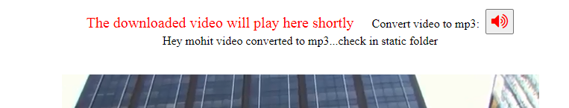

**As you can see the video and the mp3 file have been stored in static folder.**

